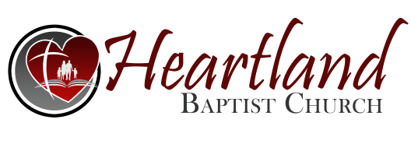
Wednesday, 7-26-2023
Pastor Gruber

Biblical ELEMENTS of Music PART 4
Psalm 40:1-3
- Music Should Have a Biblical THEME
- Music Should Have a Biblical TEST
- It Should Pass the TEST of SEPARATION
- It Should Pass the TEST of SUBMISSION
Today...
- It Should Pass the TEST of ______________________ Sanctification…Setting apart, consecration
- _________________ I Timothy 1:3-4
- _________________ I Timothy 6:3
- _________________ I Timothy 3:15
_________________ Versus ___________________
Pillar… The word "pillar" means a _____________, such
as that by which a building is _________________, and
then any firm prop or support.
Ground … a ____________, or ______________
NOTE: The figure here is evidently taken from
__________________, as the use of the word pillar is. The
proper meaning of the one expression would be, that truth is
________________ by the church, as an ______________
is by a pillar; of the other, that the truth _____________ on
the church, as a house does on its _________________.

- It Should Pass the TEST of _____________________
Colossians 3:16 …dwell in you richly (fully, completely) in all (the whole) wisdom…
_____________ Versus _________________

- It Should Pass the TEST of _____________________
Ezekiel 22:23-28; 44:23
____________ Versus ___________________

- It Should Pass the TEST of ___________________ (Serious)
I Peter 5:8
sober – serious ___________, _______________
vigilant – __________, _______________
_____________ Versus __________________

- It Should Pass the TEST of _____________________
I Corinthians 10:21; I Timothy 4:1
__________________ Versus _______________
- AVOID ________________
Cup of the Lord vs. Cup of devils
Table of the Lord vs. Table of devils
- AVOID ________________
…some shall depart…

